

**FACULTY OF INFORMATION TECHNOLOGIES**

**DEPARTMENT OF INFORMATION SYSTEMS MANAGEMENT**

**MACHINE VISION**

*Report*

**Laboratory work #5**

|  |  |
| --- | --- |
|  | **Done by: Sailaubekova Zhansaya** |
|  | **Checked by: Auezova Anel** |

**Almaty 2015**

Discrete Fourier Transform

#include "opencv2/core/core.hpp"

#include "opencv2/imgproc/imgproc.hpp"

#include "opencv2/highgui/highgui.hpp"

#include <iostream>

#include "opencv2/imgproc/types_c.h"

#include "opencv2/highgui/highgui_c.h"

using namespace std;

using namespace cv;

int main(int argc, char ** argv)

{

const char* filename = argc >=2 ? argv[1] : "/Users/Zhansaya/Desktop/fruits.jpg";

Mat I = imread(filename, CV_LOAD_IMAGE_GRAYSCALE);

if( I.empty())

return -1;

Mat padded; //expand input image to optimal size

int m = getOptimalDFTSize( I.rows );

int n = getOptimalDFTSize( I.cols ); // on the border add zero values

copyMakeBorder(I, padded, 0, m - I.rows, 0, n - I.cols, BORDER_CONSTANT, Scalar::all(0));

Mat planes[] = {Mat_<float>(padded), Mat::zeros(padded.size(), CV_32F)};

Mat complexI;

merge(planes, 2, complexI); // Add to the expanded another plane with zeros

dft(complexI, complexI); // this way the result may fit in the source matrix

// compute the magnitude and switch to logarithmic scale

// => log(1 + sqrt(Re(DFT(I))^2 + Im(DFT(I))^2))

split(complexI, planes); // planes[0] = Re(DFT(I), planes[1] = Im(DFT(I))

magnitude(planes[0], planes[1], planes[0]);// planes[0] = magnitude

Mat magI = planes[0];

magI += Scalar::all(1); // switch to logarithmic scale

log(magI, magI);

// crop the spectrum, if it has an odd number of rows or columns

magI = magI(Rect(0, 0, magI.cols & -2, magI.rows & -2));

// rearrange the quadrants of Fourier image so that the origin is at the image center

int cx = magI.cols/2;

int cy = magI.rows/2;

Mat q0(magI, Rect(0, 0, cx, cy)); // Top-Left - Create a ROI per quadrant

Mat q1(magI, Rect(cx, 0, cx, cy)); // Top-Right

Mat q2(magI, Rect(0, cy, cx, cy)); // Bottom-Left

Mat q3(magI, Rect(cx, cy, cx, cy)); // Bottom-Right

Mat tmp; // swap quadrants (Top-Left with Bottom-Right)

q0.copyTo(tmp);

q3.copyTo(q0);

tmp.copyTo(q3);

q1.copyTo(tmp); // swap quadrant (Top-Right with Bottom-Left)

q2.copyTo(q1);

tmp.copyTo(q2);

normalize(magI, magI, 0, 1, CV_MINMAX); // Transform the matrix with float values into a

// viewable image form (float between values 0 and 1).

imshow("Input Image" , I ); // Show the result

imshow("spectrum magnitude", magI);

waitKey();

return 0;

}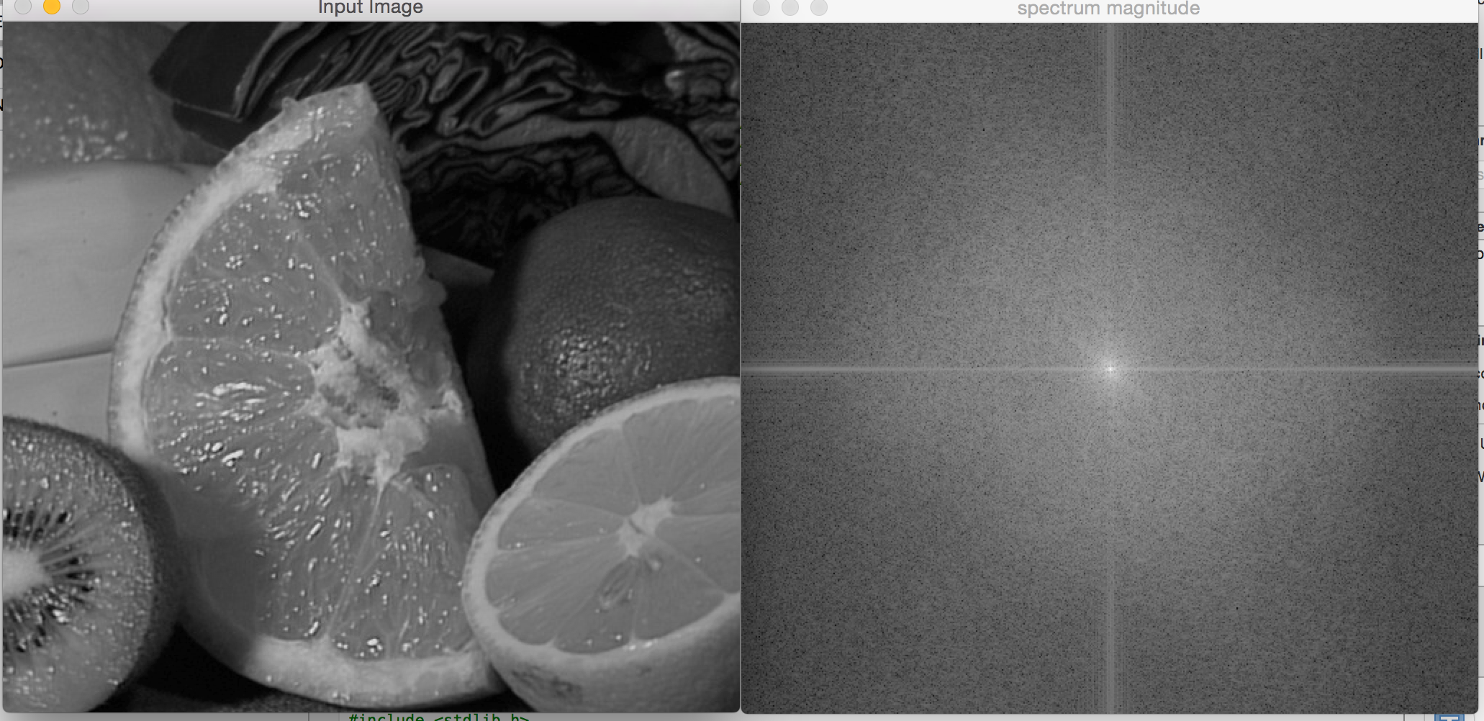

Smothing images

#include <iostream>

#include <vector>

#include "opencv2/imgproc/imgproc.hpp"

#include "opencv2/imgcodecs.hpp"

#include "opencv2/highgui/highgui.hpp"

#include "opencv2/features2d/features2d.hpp"

//using namespace std;

using namespace cv;

/// Global Variables

int DELAY_CAPTION = 1500;

int DELAY_BLUR = 100;

int MAX_KERNEL_LENGTH = 31;

Mat src; Mat dst;

char window_name[] = "Smoothing Demo";

/// Function headers

int display_caption( const char* caption );

int display_dst( int delay );

int main(void)

{

namedWindow( window_name, WINDOW_AUTOSIZE );

/// Load the source image

src = imread("/Users/Zhansaya/Desktop/fruits.jpg", 1);

if( display_caption( "Original Image" ) != 0 ) { return 0; }

dst = src.clone();

if( display_dst( DELAY_CAPTION ) != 0 ) { return 0; }

/// Applying Homogeneous blur

if( display_caption( "Homogeneous Blur" ) != 0 ) { return 0; }

for ( int i = 1; i < MAX_KERNEL_LENGTH; i = i + 2 )

{ blur( src, dst, Size( i, i ), Point(-1,-1) );

if( display_dst( DELAY_BLUR ) != 0 ) { return 0; } }

/// Applying Gaussian blur

if( display_caption( "Gaussian Blur" ) != 0 ) { return 0; }

for ( int i = 1; i < MAX_KERNEL_LENGTH; i = i + 2 )

{ GaussianBlur( src, dst, Size( i, i ), 0, 0 );

if( display_dst( DELAY_BLUR ) != 0 ) { return 0; } }

/// Applying Median blur

if( display_caption( "Median Blur" ) != 0 ) { return 0; }

for ( int i = 1; i < MAX_KERNEL_LENGTH; i = i + 2 )

{ medianBlur ( src, dst, i );

if( display_dst( DELAY_BLUR ) != 0 ) { return 0; } }

/// Applying Bilateral Filter

if( display_caption( "Bilateral Blur" ) != 0 ) { return 0; }

for ( int i = 1; i < MAX_KERNEL_LENGTH; i = i + 2 )

{ bilateralFilter ( src, dst, i, i*2, i/2 );

if( display_dst( DELAY_BLUR ) != 0 ) { return 0; } }

/// Wait until user press a key

display_caption( "End: Press a key!" );

waitKey(0);

return 0;

}

int display_caption( const char* caption )

{

dst = Mat::zeros( src.size(), src.type() );

putText( dst, caption,

Point( src.cols/4, src.rows/2),

FONT_HERSHEY_COMPLEX, 1, Scalar(255, 255, 255) );

imshow( window_name, dst );

int c = waitKey( DELAY_CAPTION );

if( c >= 0 ) { return -1; }

return 0;

}

int display_dst( int delay )

{

imshow( window_name, dst );

int c = waitKey ( delay );

if( c >= 0 ) { return -1; }

return 0;

}

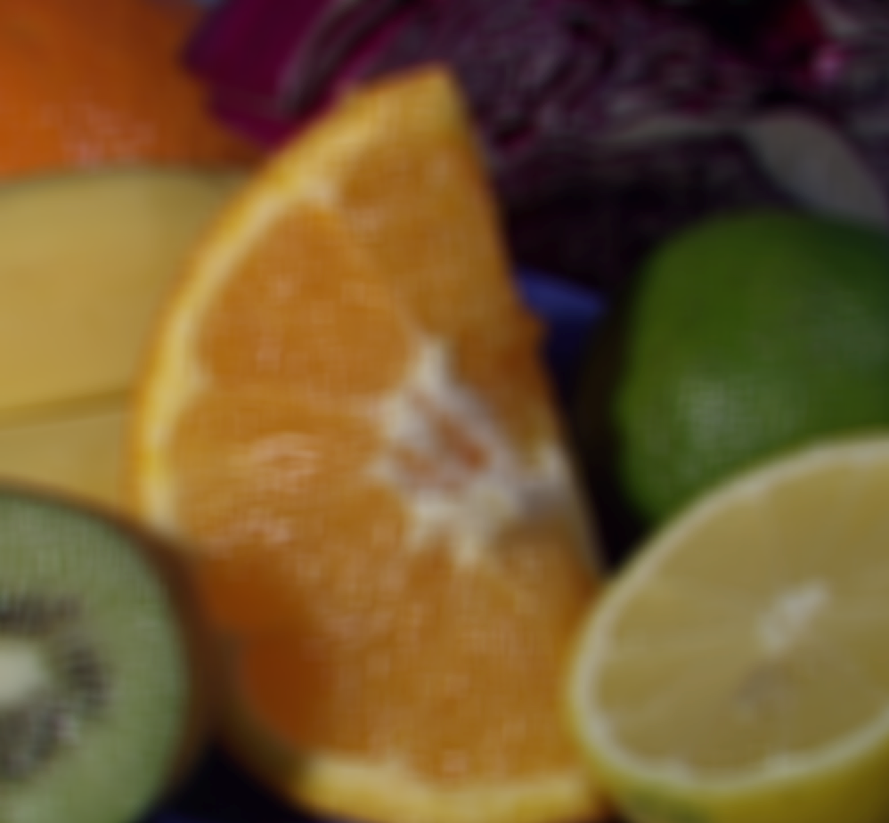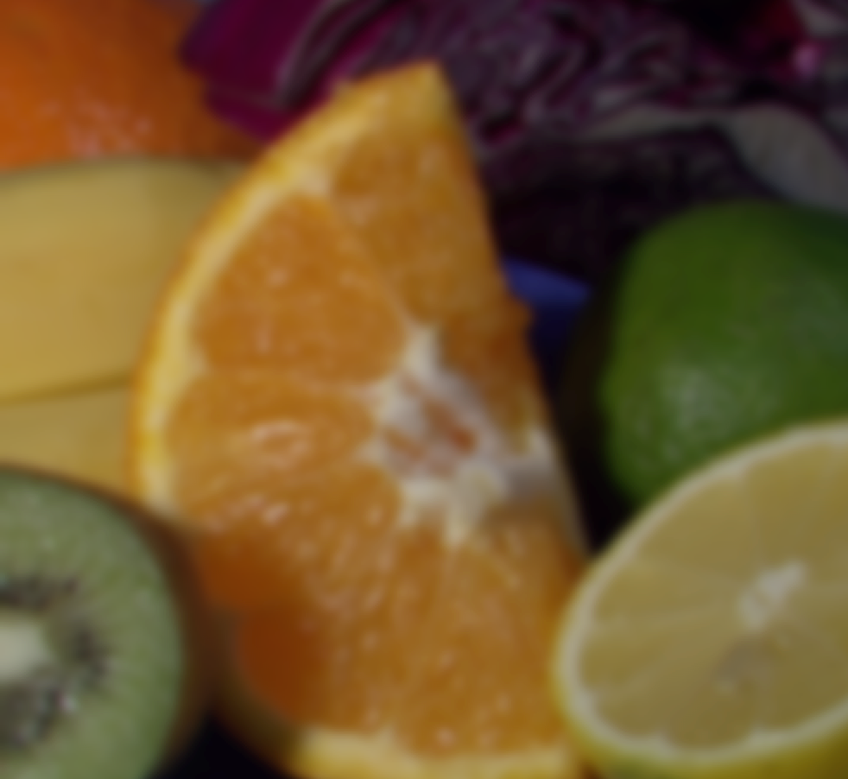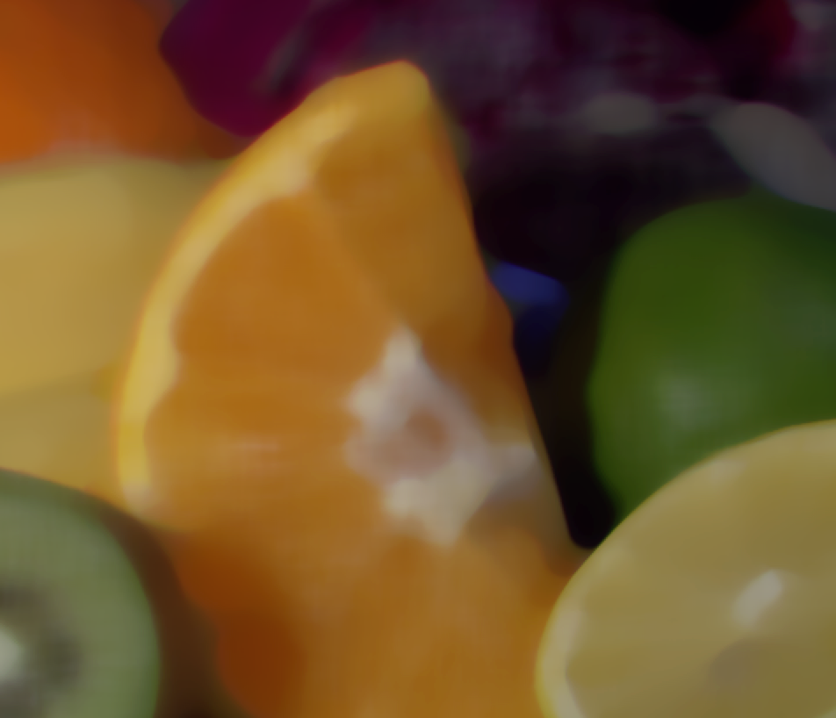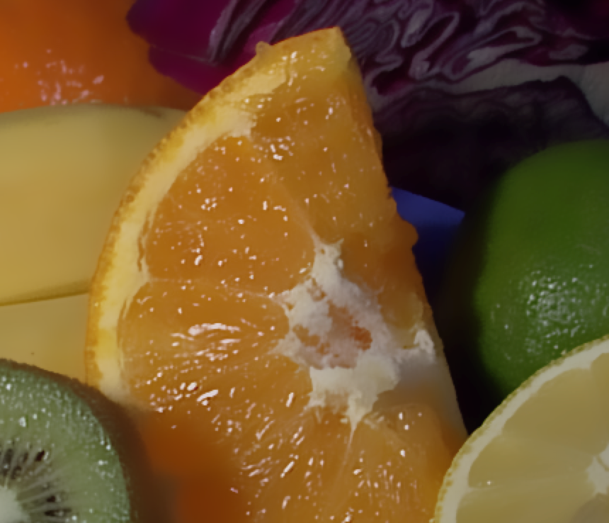

Image Pyramids

#include "opencv2/imgproc/imgproc.hpp"

#include "opencv2/imgcodecs.hpp"

#include "opencv2/highgui/highgui.hpp"

#include <math.h>

#include <stdlib.h>

#include <stdio.h>

using namespace cv;

/// Global variables

Mat src, dst, tmp;

const char* window_name = "Pyramids Demo";

int main( void )

{

/// General instructions

printf( "\n Zoom In-Out demo \n " );

printf( "------------------ \n" );

printf( " * [u] -> Zoom in \n" );

printf( " * [d] -> Zoom out \n" );

printf( " * [ESC] -> Close program \n \n" );

/// Test image - Make sure it s divisible by 2^{n}

src = imread( "/Users/Zhansaya/Desktop/fruits.jpg" );

if( src.empty() )

{ printf(" No data! -- Exiting the program \n");

return -1; }

tmp = src;

dst = tmp;

/// Create window

namedWindow( window_name, WINDOW_AUTOSIZE );

imshow( window_name, dst );

/// Loop

for(;;)

{

int c;

c = waitKey(10);

if( (char)c == 27 )

{ break; }

if( (char)c == 'u' )

{ pyrUp( tmp, dst, Size( tmp.cols*2, tmp.rows*2 ) );

printf( "** Zoom In: Image x 2 \n" );

}

else if( (char)c == 'd' )

{ pyrDown( tmp, dst, Size( tmp.cols/2, tmp.rows/2 ) );

printf( "** Zoom Out: Image / 2 \n" );

}

imshow( window_name, dst );

tmp = dst;

}

return 0;

}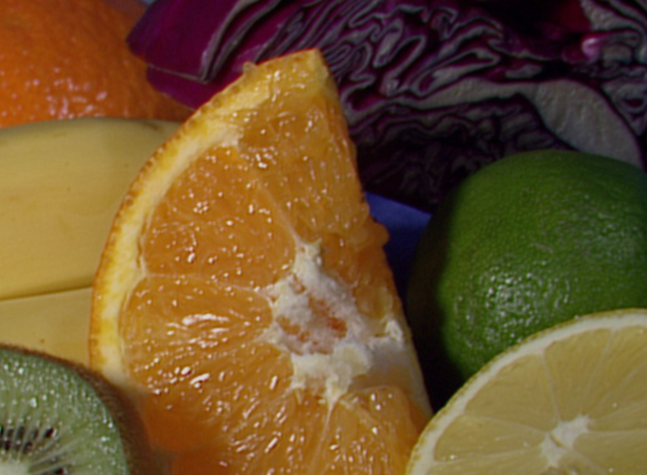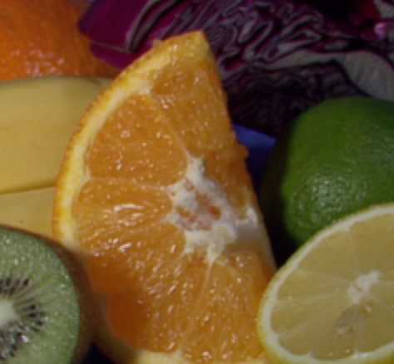

Making your own linear filters

#include "opencv2/imgproc/imgproc.hpp"

#include "opencv2/imgcodecs.hpp"

#include "opencv2/highgui/highgui.hpp"

#include <stdlib.h>

#include <stdio.h>

using namespace cv;

int main ( int, char** argv )

{

/// Declare variables

Mat src, dst;

Mat kernel;

Point anchor;

double delta;

int ddepth;

int kernel_size;

const char* window_name = "filter2D Demo";

int c;

/// Load an image

src = imread( argv[1] );

src = imread("/Users/Zhansaya/Desktop/fruits.jpg");

if( src.empty() )

{ return -1; }

/// Create window

namedWindow( window_name, WINDOW_AUTOSIZE );

/// Initialize arguments for the filter

anchor = Point( -1, -1 );

delta = 0;

ddepth = -1;

/// Loop - Will filter the image with different kernel sizes each 0.5 seconds

int ind = 0;

for(;;)

{

c = waitKey(500);

/// Press 'ESC' to exit the program

if( (char)c == 27 )

{ break; }

/// Update kernel size for a normalized box filter

kernel_size = 3 + 2*( ind%5 );

kernel = Mat::ones( kernel_size, kernel_size, CV_32F )/ (float)(kernel_size*kernel_size);

/// Apply filter

filter2D(src, dst, ddepth , kernel, anchor, delta, BORDER_DEFAULT );

imshow( window_name, dst );

ind++;

}

return 0;

}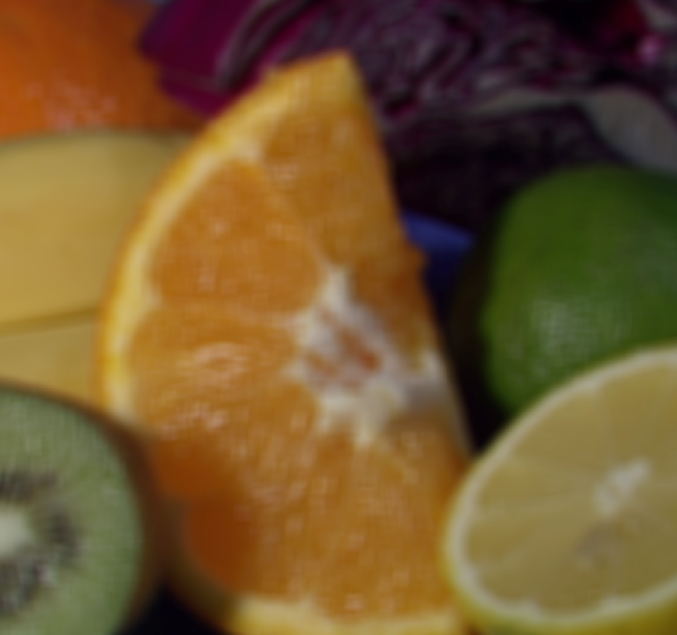

Sobel Derivatives

#include "opencv2/imgproc/imgproc.hpp"

#include "opencv2/imgcodecs.hpp"

#include "opencv2/highgui/highgui.hpp"

#include <stdlib.h>

#include <stdio.h>

using namespace cv;

int main( int, char** argv )

{

Mat src, src_gray;

Mat grad;

const char* window_name = "Sobel Demo - Simple Edge Detector";

int scale = 1;

int delta = 0;

int ddepth = CV_16S;

/// Load an image

src = imread( argv[1] );

src = imread("/Users/Zhansaya/Desktop/fruits.jpg");

if( src.empty() )

{ return -1; }

GaussianBlur( src, src, Size(3,3), 0, 0, BORDER_DEFAULT );

/// Convert it to gray

cvtColor( src, src_gray, COLOR_RGB2GRAY );

/// Create window

namedWindow( window_name, WINDOW_AUTOSIZE );

/// Generate grad_x and grad_y

Mat grad_x, grad_y;

Mat abs_grad_x, abs_grad_y;

/// Gradient X

//Scharr( src_gray, grad_x, ddepth, 1, 0, scale, delta, BORDER_DEFAULT );

Sobel( src_gray, grad_x, ddepth, 1, 0, 3, scale, delta, BORDER_DEFAULT );

convertScaleAbs( grad_x, abs_grad_x );

/// Gradient Y

//Scharr( src_gray, grad_y, ddepth, 0, 1, scale, delta, BORDER_DEFAULT );

Sobel( src_gray, grad_y, ddepth, 0, 1, 3, 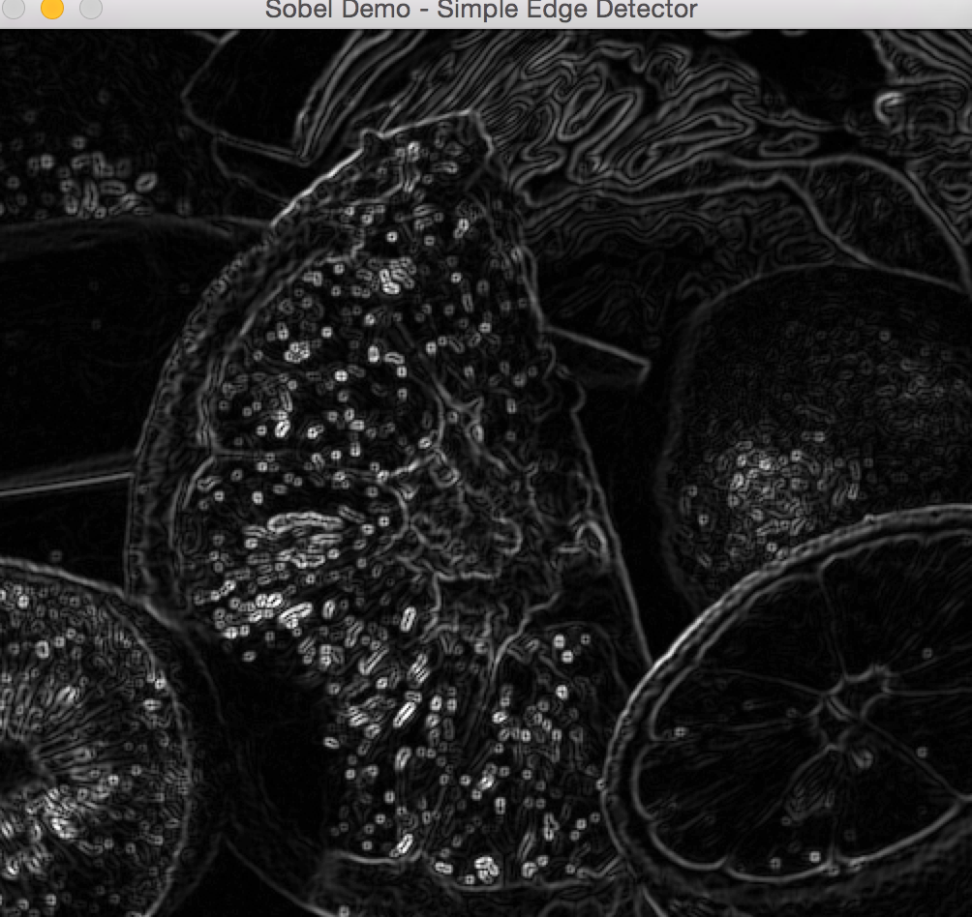scale, delta, BORDER_DEFAULT );

convertScaleAbs( grad_y, abs_grad_y );

/// Total Gradient (approximate)

addWeighted( abs_grad_x, 0.5, abs_grad_y, 0.5, 0, grad );

imshow( window_name, grad );

waitKey(0);

return 0;

}

Laplace operator

#include "opencv2/imgproc/imgproc.hpp"

#include "opencv2/imgcodecs.hpp"

#include "opencv2/highgui/highgui.hpp"

#include <stdlib.h>

#include <stdio.h>

using namespace cv;

int main( int, char** argv )

{

Mat src, src_gray, dst;

int kernel_size = 3;

int scale = 1;

int delta = 0;

int ddepth = CV_16S;

const char* window_name = "Laplace Demo";

/// Load an image

src = imread( argv[1] );

src = imread("/Users/Zhansaya/Desktop/fruits.jpg");

if( src.empty() )

{ return -1; }

/// Remove noise by blurring with a Gaussian filter

GaussianBlur( src, src, Size(3,3), 0, 0, BORDER_DEFAULT );

/// Convert the image to grayscale

cvtColor( src, src_gray, COLOR_RGB2GRAY );

/// Create window

namedWindow( window_name, WINDOW_AUTOSIZE );

/// Apply Laplace function

Mat abs_dst;

Laplacian( src_gray, dst, ddepth, kernel_size, scale, delta, BORDER_DEFAULT );

convertScaleAbs( dst, abs_dst );

/// Show what you got

imshow( window_name, abs_dst );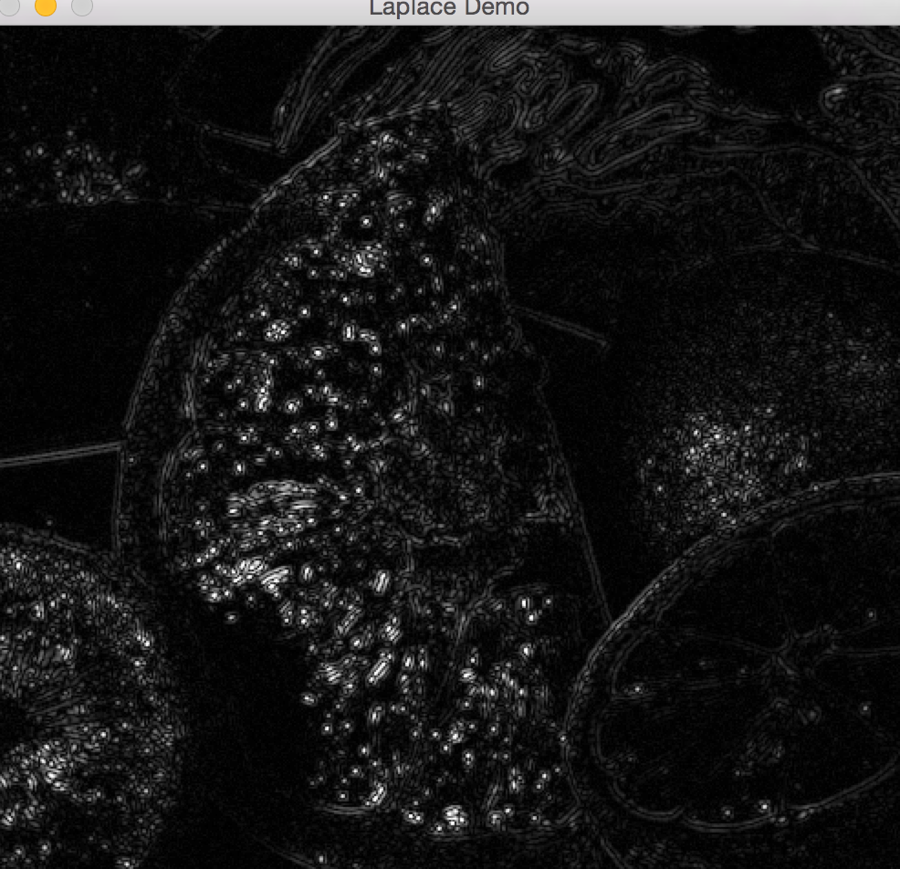

waitKey(0);

return 0;

}